**Instructions: (a) Write your Roll. No. in the space provided. (b) Nothing should be written on the question paper. Writing on your question paper will disqualify you to sit in the Examination.**

**(14x5 = 70 marks)**

***Note: Attempt all five questions. Each question carries fourteen (14) marks.***

**Question-1: a.** Explain normalization in the context of SQL databases.  **4 Marks**

**b.** Make use of your knowledge of SQL and outline the difference between the INNER JOIN and OUTER JOIN. **4 Marks**

**c.** List the various functions of DBMS with query and example**. 3 Marks**

**d.** List the various SET operators used in SQL with their functionality. **3 Marks**

**Question-2:**

**Case Study**

A medium-sized Company deals with industrial applications of computers. The Company delivers various products to its customers ranging from a single application program to complete installation of hardware with customized software. The Company employs various experts, consultants, and supporting staff. All personnel are employed on a long-term basis, i.e. there is no short-term or temporary staff. Although the Company is somehow structured for administrative purposes (that is, it is divided into departments headed by department managers) all projects are carried out in an interdisciplinary way. For each project a project team is selected, grouping employees from different departments, and a Project Manager (also an employee of the Company) is appointed who is entirely and exclusively responsible for the control of the project, quite independently of the Company's hierarchy.

**a.** Discover various types of data that need to be used in the system. Also, give the format of the file structures for the same.  **4+5=9 Marks**

**b.** Discuss the changes that you will have to incorporate each time a new functionality is to be added to the system?  **5 Marks**

**Question-3: a.** Differentiate between DROP and TRUNCATE commands of SQL with suitable examples.

**4 Marks**

**b.** Explain the three-level architecture of DBMS with the diagram. **5 Marks**

**c.** Discuss the purpose of GROUP BY and HAVING clauses in SQL with suitable examples. **5 Marks**

**Question-4:**

Consider the table Product (pid, pname, price, category, manufacturer) and give the

query to generate the below given reports

a. Product name who have maximum price

b. Product name who have minimum price

c. The average price of all products

d. The number of products in the company

e. Specify the various catogory in the company

**OR**

Illustrate the various types of Joins in SLQ with suitable examples. **5 Marks**

Develop a relation Employee as below given specification and constraints.

Marks)

• Make sure ID range is between 1000 and 4000

• Create the FK constraint as on deleting any department the emp table id

should change to Null **5 Marks**

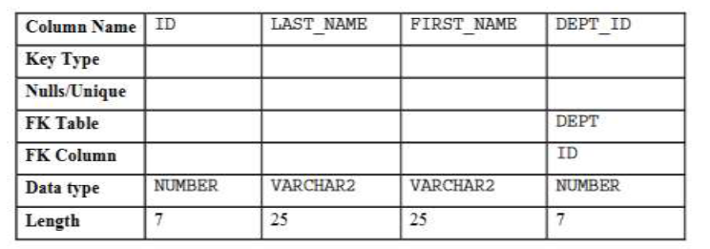

Write suitable query to perform following actions.

• Modify the EMP table to allow for longer employee last names of size

as 50

• Confirm your modification. **4 Marks**

**Question-5:**

|  |
| --- |
| Give all the correct query options from the list below   1. create table EMPLOYEES(empno number,name varchar2(50) not null,job varchar2(50),manager number, hiredate date,salary number(7,2),commission number(7,2),deptno number,constraint pk_employees primary key (empno),constraint fk_employees_deptno foreign key (deptno) references DEPARTMENTS (deptno)); 2. create table EMPLOYEES(empno numbers,name varchar2(50) not null,job varchar2(50),manager numbers, hiredate date,salary numbers(7,2),commission numbers(7,2),deptno numbers,constraint pk_employees primary key (empno),constraint fk_employees_deptno foreign key (deptno) references DEPARTMENTS (deptno)); 3. create table EMPLOYEE(empno number,name varchar2(50) not null,job varchar2(50),manager number, hiredate date,salary number(7,2),commission number(7,2),deptno number,constraint pk_employees primary key (empno),constraint fk_employees_deptno foreign key (deptno) references DEPARTMENTS (deptno)); 4. insert into EMPLOYEES (empno, name, job, salary, deptno) values (4101,'Sam Smith','Programmer',5000,4001 ); 5. insert into EMPLOYEES (empno, name, job, salary, deptno) values (4101,Sam Smith,Programmer,5000,4001 ); 6. create table student(ID char(4) primary key,Fname varchar2(10),deptID char(4)); 7. create table student(ID char(4),Fname varchar2(10),deptID char(4),constraint primary key (ID),foreign key (deptID) references dept(deptID)); 8. select dept_no,max(salary) from employess GROUP BY dept_no HAVING max(salary)>10000; 9. select deptno,max(salary) from employess GROUP BY deptno HAVING max(salary)>10000; |

**4.5 Marks**

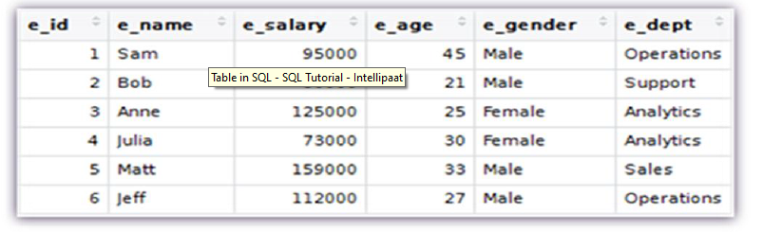

List of queries are

• INSERT

• CREATE

• ALTER

• DELETE

• REMOVE

• UPDATE

• DROP

**3.5 Marks**

Give the answers for the below given functions

a. ROUND(56.678,2)

b. MOD(3401,100)

c. FLOOR(2.83)

**3 Marks**

Write a join query to create a view with the below attributes and table names as given below.

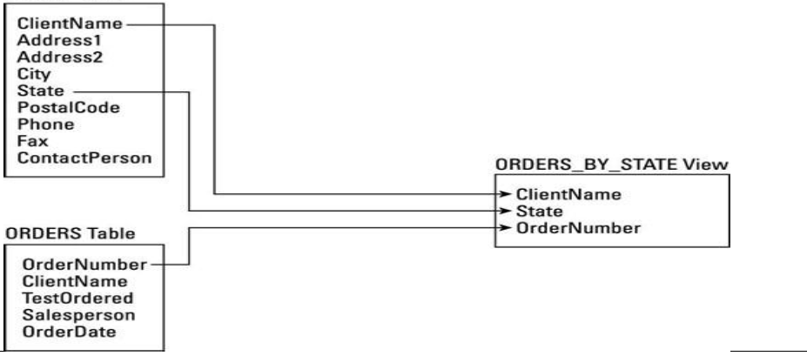

**3 Marks**